Phase 5

Lesson 3

**Create an EBS Volume**

Steps:

1. Selecting the **volume** tab in the EC2 dashboard

2. Creating a new volume by clicking on **Create**

3. Selecting the volume type according to the project requirement

4. Creating a new volume by specifying the size and defining the zone

5. Verifying the new volume created on the volume console and its availability

Step 1,2:

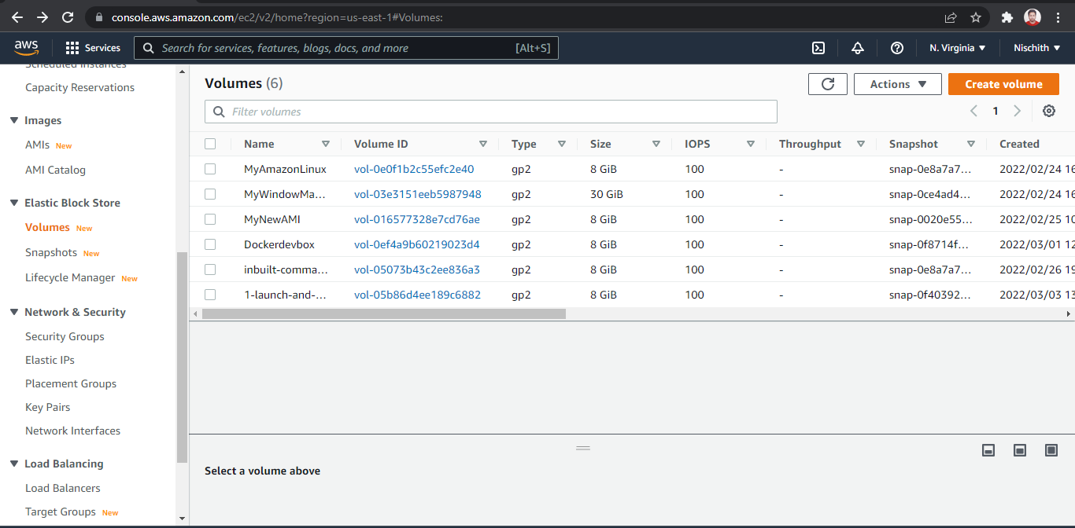

Step 3:

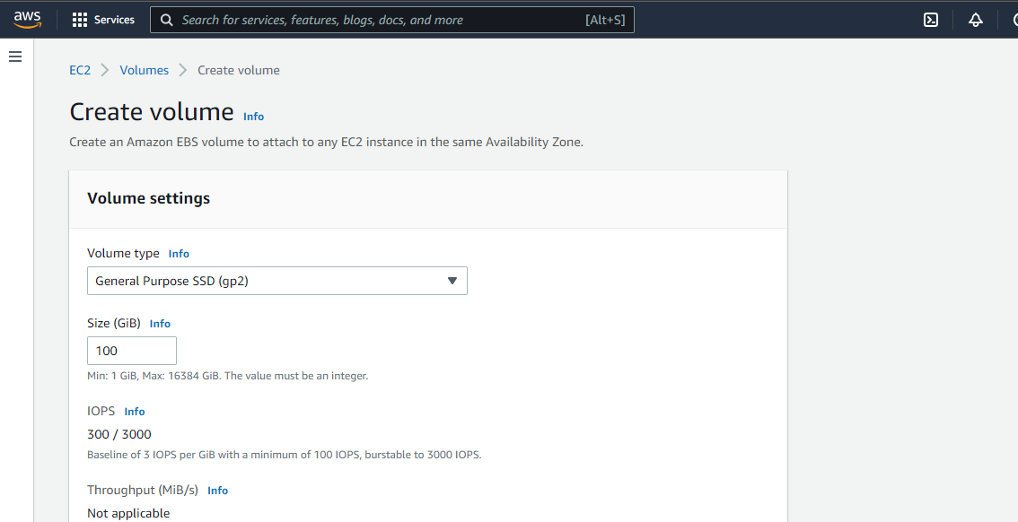

Step 4:

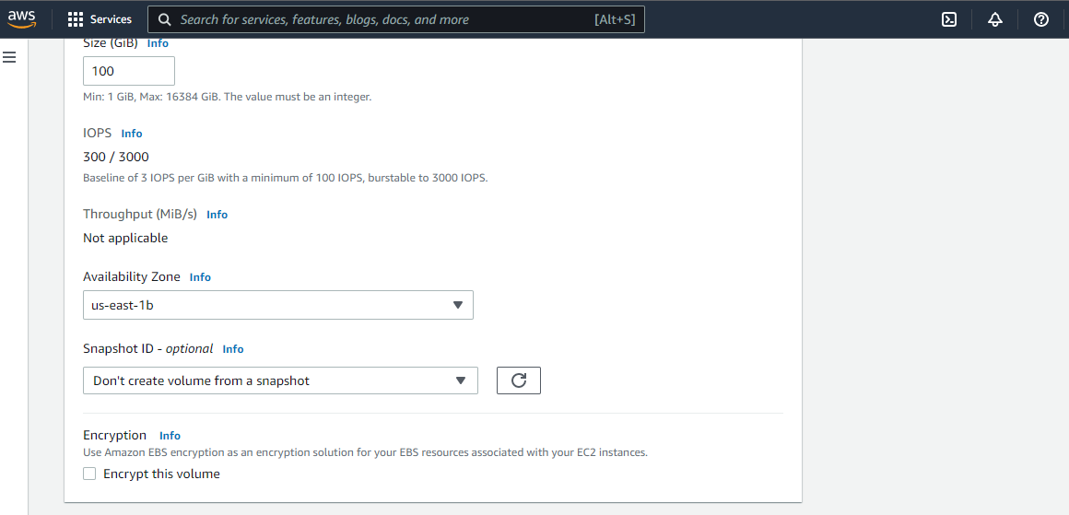

Step 5:

